Bdominiq

Homework-5 (Interfaces): Alternative sketches

**Sketch-1**

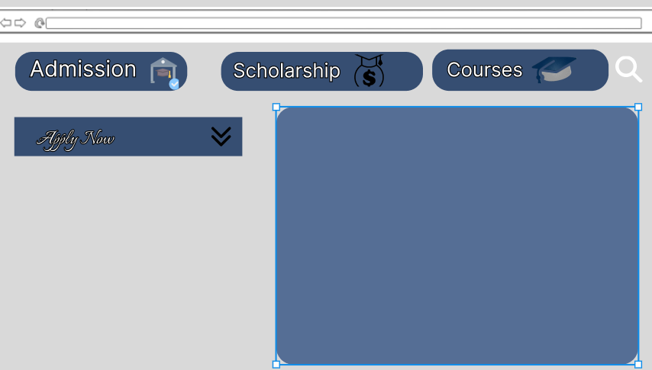

During our user research, we uncovered three key priorities among students: admission, scholarships, and available courses, all of which have been detailed in our report. Reflecting on our group's previous work, I opted to incorporate icons, believing they could significantly aid students in locating these essential elements more efficiently. Rejecting the idea of utilizing cards due to unnecessary space consumption, I instead designed them to be small and positioned at the top for enhanced accessibility. Additionally, supplementary features were presented in a dropdown menu format, commencing with "apply now," as our study indicated that a dropdown menu streamlines user choices, which ultimately enhances user experience.

**Sketch-2**

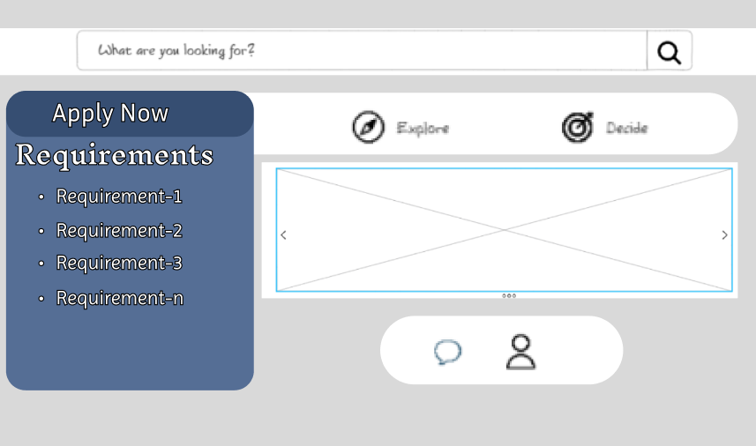

In this design iteration, I made the decision to prominently display the admission requirements, ensuring they are readily accessible without the need to navigate through additional options. Furthermore, I enhanced the clarity of the contact information for inquiries, ensuring that students can easily locate the button whenever they need to reach out to the university. Similarly, I improved the visibility of the portal for login or registration to the website, streamlining the user experience and facilitating seamless interaction with the platform.

**Sketch-3**

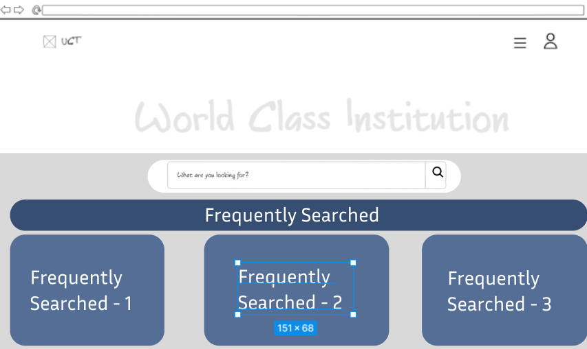

In this third design , I prioritized the inclusion of frequently searched and clicked actions to streamline students' access to their desired information, leveraging the tendency for students to seek similar resources. Building upon our research, which revealed a consensus around three primary areas of interest, this approach aims to enhance the user experience by facilitating quicker access to pertinent information. Additionally, I optimized the view by reducing the size of the search box from our group's original design, ensuring a more responsive and visually appealing interface.